

Year 10 General Science
Physics 1 Test: Motion

SECTION 1: MULTIPLE CHOICE (1 mark each)
Circle your answer on the multiple choice answer sheet.

- Displacement is
- the same as distance travelled.
- the straight-line distance between two places.
- the straight-line distance and direction between two points.
- how fast something is travelling.

- A heavy vehicle is slower to accelerate and harder to stop than a light vehicle. This is because of
  - inertia.
  - velocity.
  - impact.
  - gravity.

The next three questions refer to the following diagram
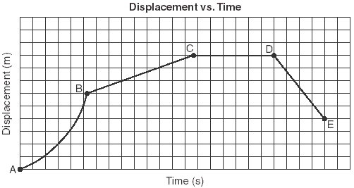

- The motion between A and B would be described as
  - constant speed
  - constant velocity
  - acceleration
  - deceleration

- 55 kg is the same as
  - 5.5 N
  - 22 N
  - 5.5 g
  - 550 N

- A speaker uses 100 J of energy to produce 50 J of sound, 20 J of mechanical energy and 30 J of heat. What is its efficiency?
  - 100%
  - 50%
  - 20%
  - 30%

- Which of these is not an example of a force?
  - push
  - pull
  - twist
  - heat

- Which of the following is not an effect of a force?
- changing the speed of an object
- changing the direction of an object’s motion
- changing the size of an object
- changing the shape of an object

- Study the diagram below that shows the forces involved in an aeroplane.
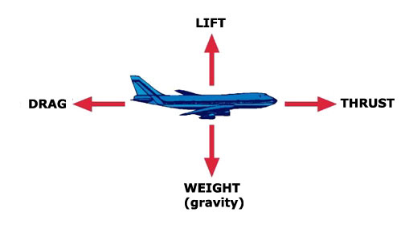
If the aeroplane is travelling forwards at constant velocity and at constant altitude (height) which statement is correct about the forces involved.
- The drag and the thrust are unbalanced.
- The weight and the lift are unbalanced.
- The drag and the thrust are balanced.
- All the forces are balanced.

- Which statement is correct about the forces shown in the diagram below?
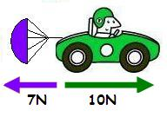
- The resultant force is 17N.
- The car will decelerate (slow down).
- The car will accelerate (speed up).
- The car will travel at constant speed.
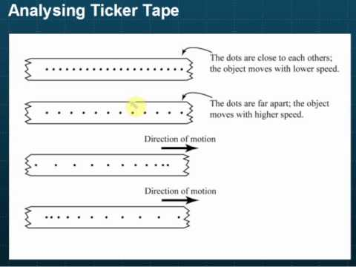
- The ticker tape shows

  - acceleration
  - constant velocity
  - negative acceleration (deceleration)
  - an object at rest

SECTION 2: WRITTEN
Write all answers in the spaces provided. Show working. If you need more space, ask for some lined paper
Formulae you might need:

speed = distance Wt = m x g Ek= ½ m v² Ep= mxgxh
time
a = v-u g = 10 m/s/s
t

ɳ= useful output x 100
input

Ep= mgh Ek= ½ mv²

- A car was in a race. It took 25 seconds to go 500 m in distance. Determine the average speed of the car. (2)

- A skydiver is falling with a constant speed of 7 m/s. Calculate how long it will take to reach the ground 1200m below. (3)

- Indicate the direction and size of the resultant force for each of the following: (3)

a) 5N

7N

b) 40N

50N

c) 100N

60N

- A car, initially travelling at 15 m/s, accelerates for 4 seconds until its speed reaches 20 m/s. Determine its final velocity. (5)

initial speed = units

final speed = units

time = units

- A roller coaster with mass 2000 kg falls from a height of 26 m. At the bottom of the fall, its velocity is 7 ms⁻¹. Determine the efficiency of the energy transfer from potential to kinetic. (3)

m = units
h = units
g = units

potential energy = units

m = units
v = units

kinetic energy = units

End of Test /26

